Thank you for your support of our band programs!
The Band of Robinson Annual Poinsettia fundraiser
Beautiful plants from Brafford’s Greenhouse in Concord with 2 sizes & 2 colors available.
6 ½” pot contains 7-9 blooms $15 & 8” pot contains 25-30 blooms $28.
Colors available are Holiday Red & Jingle Bells (variegated leaf red/white)

Please Contact Crystal Ernst at nursecriss@hotmail.com or Mr. Andrew Carter at Andrew.Carter@Cabarrus.k12.nc.us with your order. Order on or before Monday November 28
You may pick up your poinsettias after school December 2nd in the tuba room beside the band room.
Name_____________________________________
Phone_____________________________
6 1/2 “ Red qty. ________ x $15 8” Red qty._________ x $28.
6 ½ Jingle Bells qty.________x $15 8” Jingle Bells qty. __________x $28
Total Due __________ Paid Check # __________ or Cash__________ Payment due with orders

Thank you for your support of our band programs!
The Band of Robinson Annual Poinsettia fundraiser
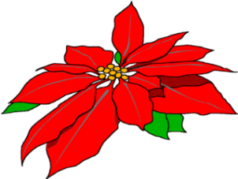
Beautiful plants from Brafford’s Greenhouse in Concord with 2 sizes & 2 colors available.
6 ½” pot contains 7-9 blooms $15 & 8” pot contains 25-30 blooms $28.
Colors available are Holiday Red & Jingle Bells (variegated leaf red/white)

Please Contact Crystal Ernst at nursecriss@hotmail.com or Mr. Andrew Carter at Andrew.Carter@Cabarrus.k12.nc.us with your order. Order on or before Monday November 28
You may pick up your poinsettias after school December 2nd in the tuba room beside the band room.
Name_____________________________________
Phone_____________________________
6 1/2 “ Red qty. ________ x $15 8” Red qty._________ x $28.
6 ½ Jingle Bells qty.________x $15 8” Jingle Bells qty. __________x $28
Total Due __________ Paid Check # __________ or Cash__________ Payment due with orders

